1

HOW TO USE BLOG CONTENT: Always include your library’s web page with information on how to access ChiltonLibrary or the access page itself. Shorten links with bit.ly, if needed.

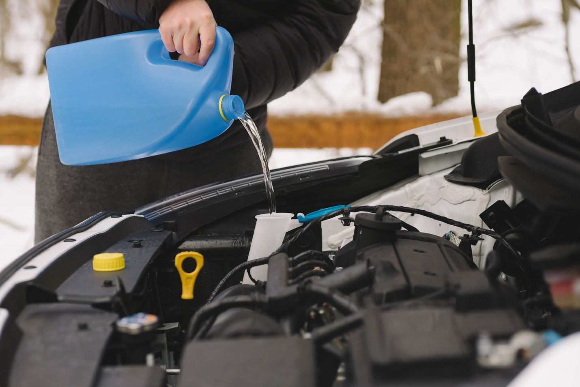 [Headline:] ChiltonLibrary for Fall and Winter Car Care

[Headline Alternative:] Prep Your Car for Cold Weather with ChiltonLibrary

In fall and winter, car owners prep their vehicles for colder, wetter weather. [INSERT YOUR LIBRARY] provides ChiltonLibrary, an automotive resource that drivers and enthusiasts can turn to for information to properly care for their cars.
Drawn from original equipment manufacturer (OEM) service information, ChiltonLibrary provides repair, maintenance, and service information for popular cars, trucks, vans, and SUVs. This resource provides step-by-step procedures as well as troubleshooting, diagnostics, illustrations, and diagrams to guide users in maintaining and fixing their vehicles.
With chilly temperatures approaching, does the heater need to be checked? ChiltonLibrary includes procedures to diagnose heater and ventilation system issues and repair them. How are the wipers? Is the washer fluid filled? With shorter days, are the headlights and other lights beaming brightly or do bulbs need to be replaced and lenses cleaned? How are the tires? ChiltonLibrary diagrams show how to evaluate tire wear and specifications help when selecting snow tires.
ChiltonLibrary can help with bigger projects, too. Is the transmission slipping or the engine tapping? ChiltonLibrary OEM information includes the procedures specific to the engine, transmission, or other component to troubleshoot, inspect, remove, and replace as needed.
[INSERT YOUR LIBRARY] offers access to ChiltonLibrary in the library during regular hours. But car repairs don’t always happen during library hours. Happily, ChiltonLibrary is an online database. With your library card, you have access using your laptop, desktop, tablet, or phone while at your car, at home, or another location.
Those with preferences can customize the way ChiltonLibrary presents information. Want to read or listen in Spanish or another language? Highlight the text and select from more than 20 languages. Want to take your phone to your car and have a procedure read to you? Select the text and tap “Listen.” Text too small? Wrong color? Want to use a different font, like OpenDyslexic? The “Text Mode” settings allow you to create the visual appearance that works best for you.
Chilton has long been a trusted source of automotive information. Along with service procedures, ChiltonLibrary includes wiring diagrams, recall and service bulletins, and labor estimating times. The VIN decoder allows you to enter a vehicle’s identification number to discover information that’s unique to the specific vehicle, such as when and where it was manufactured and what its original equipment was. It also displays real-time National Highway Traffic Safety Administration data showing what safety recalls still need to be performed.
For those learning about cars, short videos and animations explain automotive concepts, and Automotive Service Excellence-style quizzes help those prepping for ASE exams.
Every car needs maintenance from time to time. Let ChiltonLibrary boost your car care preparation for fall and winter weather.
ChiltonLibrary is free through [INSERT YOUR LIBRARY], and there when you need it. Access it from any device online at [INSERT YOUR LIBRARY’S ACCESS URL].

